**HOTEL MANAGEMENT SYSTEM**

**Service to Humanity Is Service to Mankind**

Team Members:

* Aiman Siddiqui (17k-3810)
* Saba Pervez (17k-3881)

Objective:

To construct (encode) a program that would make the hospital’s work manageable and easy. This would save their time and energy in managing information in files and papers.

Functionalities:

* It will help to save patients’ information and will be able to perform following tasks for the patients:
  + Entering new data patient.
  + Changing the previous data of a certain patient.
  + Viewing detail of the patient.
  + Searching the patients.
  + Deleting data of a certain patient.
  + Checking the recycled data.
  + Preparing Bill for the patient.
* It will help to maintain data regarding Employees which includes keepers, nurses, doctors, managers, etc. and perform following task for them.
  + Saving their details.
  + Editing their details.
  + Viewing their details.
  + Checking timings.
  + Deleting data of a certain Employee.

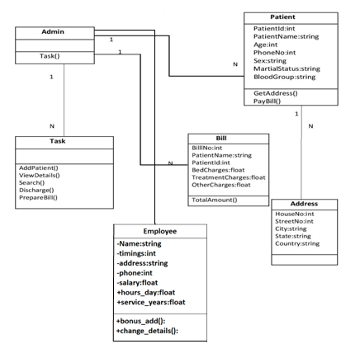

Class Diagram